**JhoGym**

**JhoGym** is a company engaged in sports, especially gym. You, as a database administrator, are currently seeking a job and applying to this gym. Before reaching the interview stage, you are asked to complete several cases to assess your query skills. Here are the cases you need to work on:

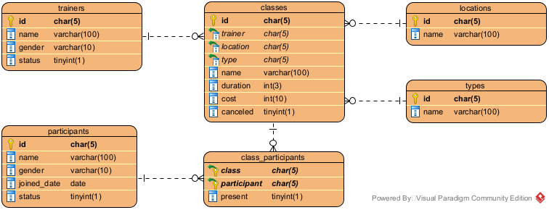

**Figure 1. Entity-Relationship Diagram**

1. Create a **table** named **feedbacks** with the following description.

**(CREATE TABLE, LIKE, BETWEEN, LENGTH)**

|  |  |  |  |
| --- | --- | --- | --- |
| **Field Name** | **Data Type** | **Length** | **Description** |
| id | CHAR | 5 | The attribute id serves as the **primary key** in this table. This attribute's format is **5 characters**, with the **word “FB”** **and 3 digits at the end** (e.g., FB001, FB025, FB255, etc.). |
| participant | CHAR | 5 | The attribute participant has a **foreign key** **relationship** with the **attribute id** in the **participants table**. If the referenced data is **changed**, either updated or deleted, then the changes will be **cascaded**. |
| class | CHAR | 5 | The attribute class has a **foreign key** **relationship** with the **attribute id** in the **classes table**. If the referenced data is **changed**, either updated or deleted, then the changes will be **cascaded**. |
| rating | INT | - | The value of the attribute rating is **required** and must be **between** **1 and 10**. |
| comment | VARCHAR | 300 | The value of the attribute comment is **required** andmust be **more than 50 characters**. |
| timestamp | DATETIME | - | The value of the attribute timestamp is **required** and must be **before July 18th, 2023**. |

1. **Insert** this data into **trainers** table.

**(INSERT)**

|  |  |  |  |
| --- | --- | --- | --- |
| **trainers** | | | |
| **id** | **name** | **gender** | **status** |
| TR021 | Sophia Adams | Female | 1 |
| TR022 | Ethan Williams | Male | 1 |
| TR023 | Ava Johnson | Female | 0 |
| TR024 | Noah Martinez | Male | 1 |
| TR025 | Isabella Brown | Female | 1 |

1. Display **Trainer ID** (obtained from attribute **id**) and **Trainer Name** (obtained from attribute **name**) for **every trainer**, where **trainer gender is** “**Male**” and has **resigned yet**.

**(CONCAT, RIGHT)**

1. Display **Participant Name** (obtained from attribute **name**) and **Joined Date** (obtained from attribute **joined_date**) for **every participant**, where **participant gender is** “**Female**” and **already join at least 320 day from the last day of 2022**.

**(DATE_FORMAT, DATEDIFF)**

1. Display **Class Name** (obtained from attribute **name** in **classes** table) and **Class Duration** (obtained from attribute **duration** in **classes** table **in hours** and **combine with** “ **Hour(s)**”) for **every class**, where the class is **held in the resort**.

**(CONCAT, LIKE)**

1. Display **unique** **Class Name** (obtained from attribute **name** in **classes** table) and **Class Cost (in USD)** (obtained from attribute **cost** in **classes** table with a **2-digit decimal**) for every **class** where **at least one student is** **not present**.

**(DATE_FORMAT)**

1. **Update** the **cost** of the classto be **10% more than the previous cost** for every **class** that lasts **more than 4.5 hours**.

**Before:**

**After:**

1. **Delete every participant** who **joined** onthe **same day** as **July 20th, 2023**.

**(DAY)**

**Before:**

**After:**  
